Trafficlights

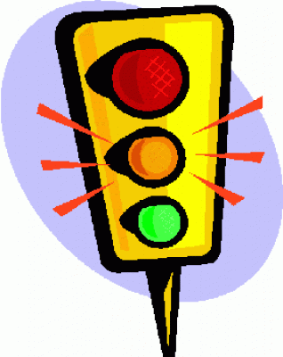

Technical Design

# Version Management

|  |  |  |  |
| --- | --- | --- | --- |
| **Date** | **Version** | **Addition** | **Whp** |
| 7-9-2015 | 1.0 | First concept | Rik van Doorn |
|  |  |  |  |

# Introduction

This document is the Technical Design for the control application for traffic points for the commune. The minimal technical requirements will be given in this document. These requirements will show ‘how’ the application will be realized.

# Table of Contents

Version Management 2

Introduction 3

Table of Contents 4

Software Architecture 5

Application Flow 6

Activity Diagram 10

Application Structure 11

# Software Architecture

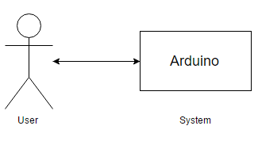

# Application Flow

### C:\Users\Rik\Downloads\Normal Flowchart - New Page (5).pngNormal Traffic Regulation:

### C:\Users\Rik\Downloads\Morning Flowchart - New Page (2).pngMorning Traffic Regulation:

### Evening Traffic Regulation:

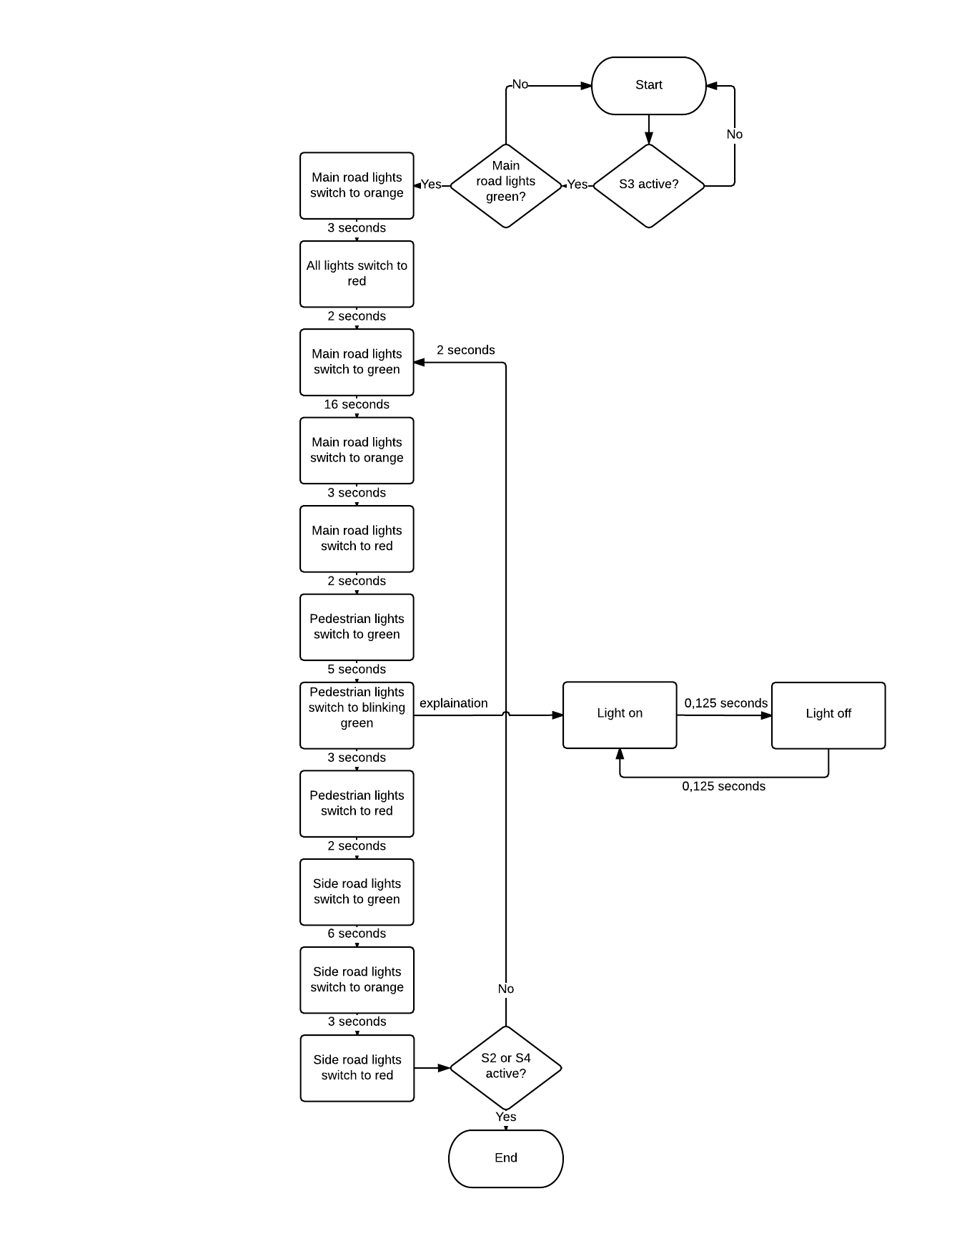

### Night Traffic Regulation:

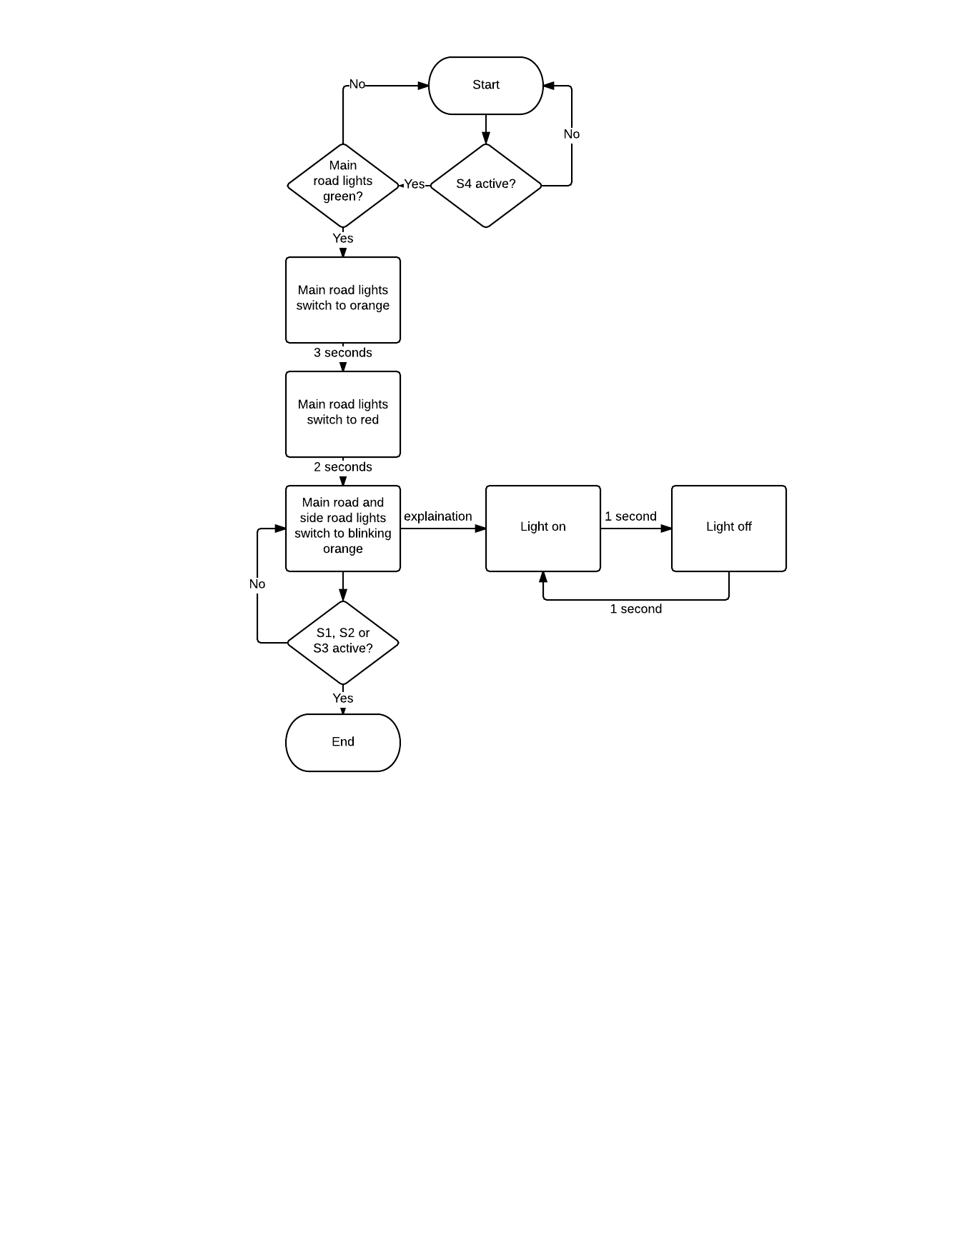

# Activity Diagram

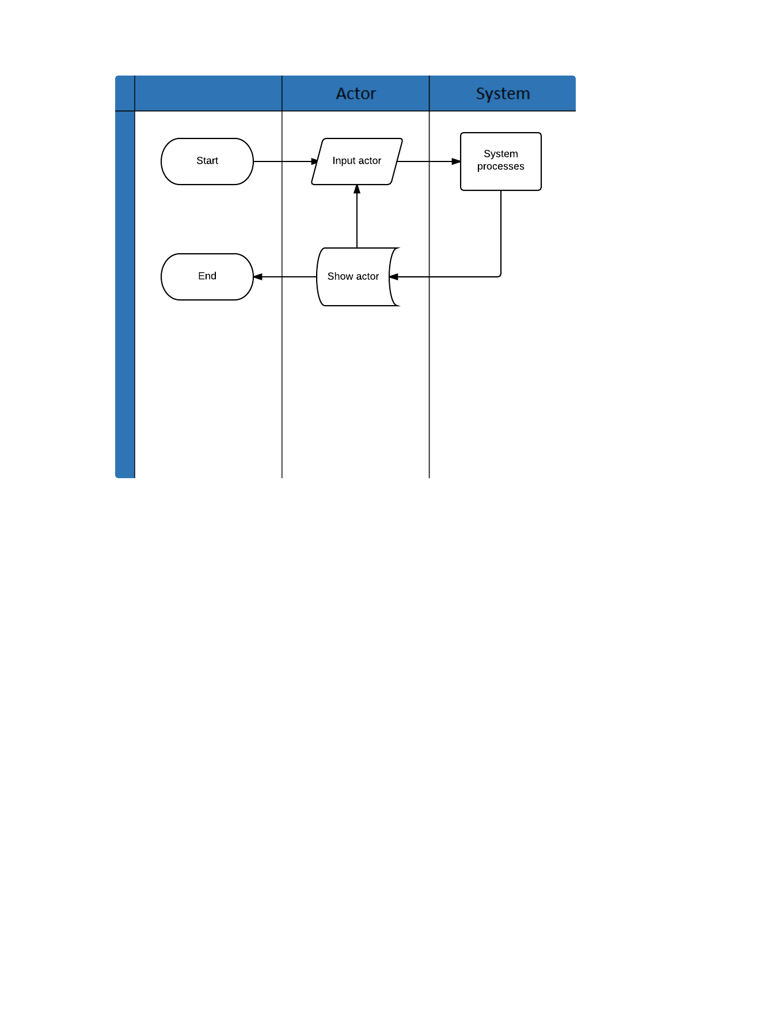

# Application Structure

